Lab -5
- Create a group named `projectteam`.

- Create a user named `leader`.
- Create three users named `member1`, `member2`, and `member3`.

- Add the `leader` user to the `projectteam` group.

- Add all three members to the `projectteam` group.
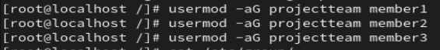
- Verify that all users belong to the correct group.

## PART 2: Project Directory Setup
### Tasks
- Create a directory named `projectdata`.
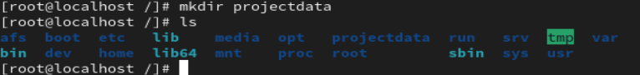
- Change the group ownership of `projectdata` to `projectteam`.

9. Set permissions so that:
- Only the leader and team members can access the directory

- Other users cannot access the directory
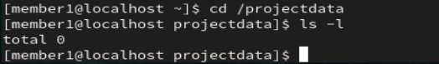
10.Ensure group members can create and modify files inside `projectdata`.
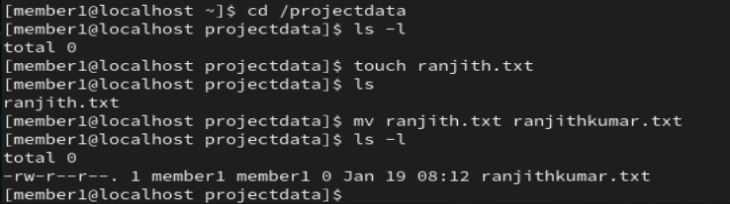
Working successfully……
11. Verify directory permissions and ownership.

## PART 3: File Access Control
### Tasks
12. Create a file named `teaminfo.txt` inside `projectdata`.
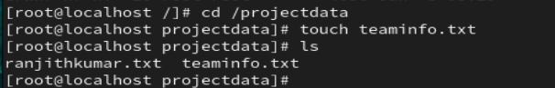
13. Set permissions so only the `projectteam` group can read and modify the file.
14. Verify file permissions.
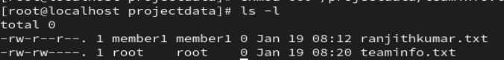

15. Test file access using one team member.
16. Test file access using a user who is not part of the group.
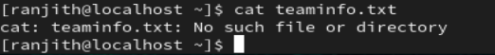
---

## PART 4: Symbolic Link Requirement

### Tasks

17. Identify a file present inside the `projectdata` directory.
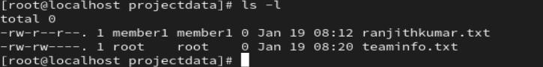
18. Create a symbolic link of this file in the **home directory of the leader**.
19. Create symbolic links of the same file in the **home directories of all team members**.
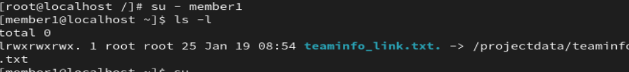
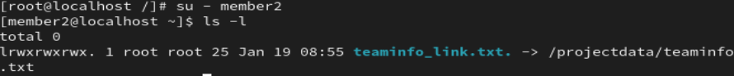
20. Verify that each symbolic link points to the correct source file.

---

## PART 5: Verification and Observation

### Tasks

21. Check inode numbers of the original file and the symbolic link.
22. Modify the original file and observe the changes through the symbolic link.
23. Remove the original file and observe the behavior of the symbolic link.
24. Recreate the original file and observe the link status.

